Laser distance meter
# Source: AI Source: Provided by: [Data Path: Persons Table -> ID Column: 1, Name_En Column: Motasem Essam] -> From: [ChatGPT] on [7/17/2026]
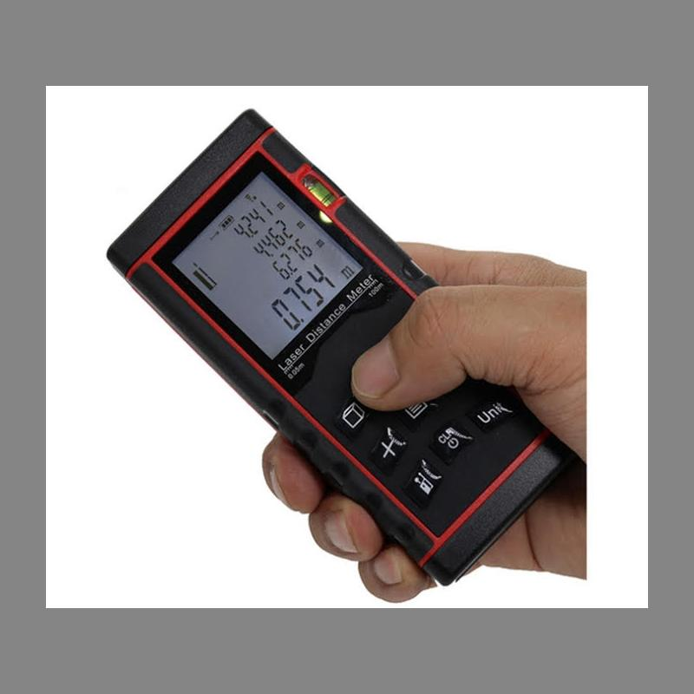
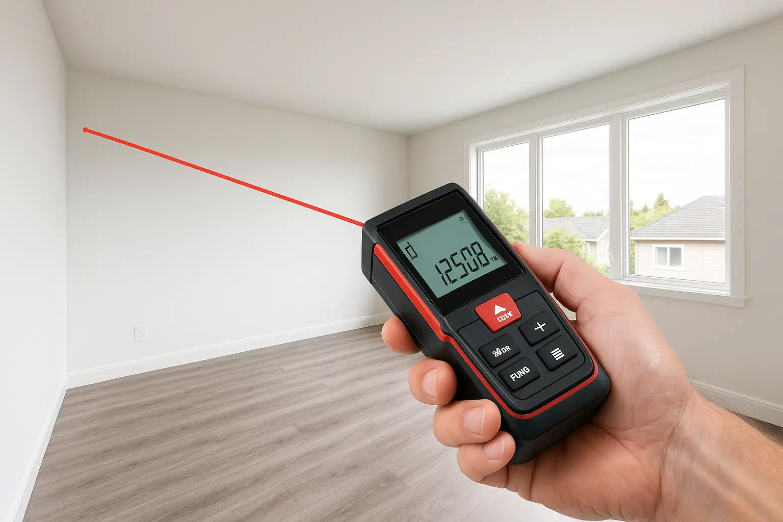
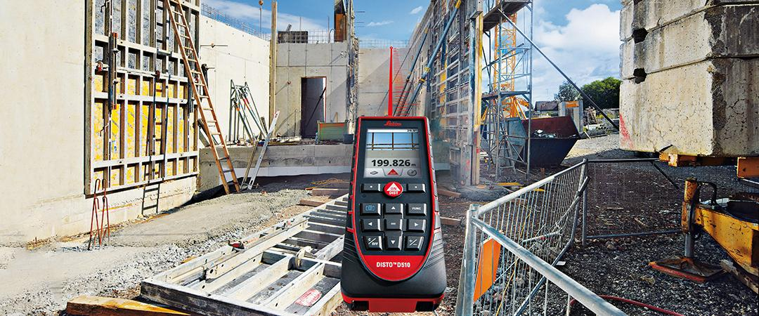
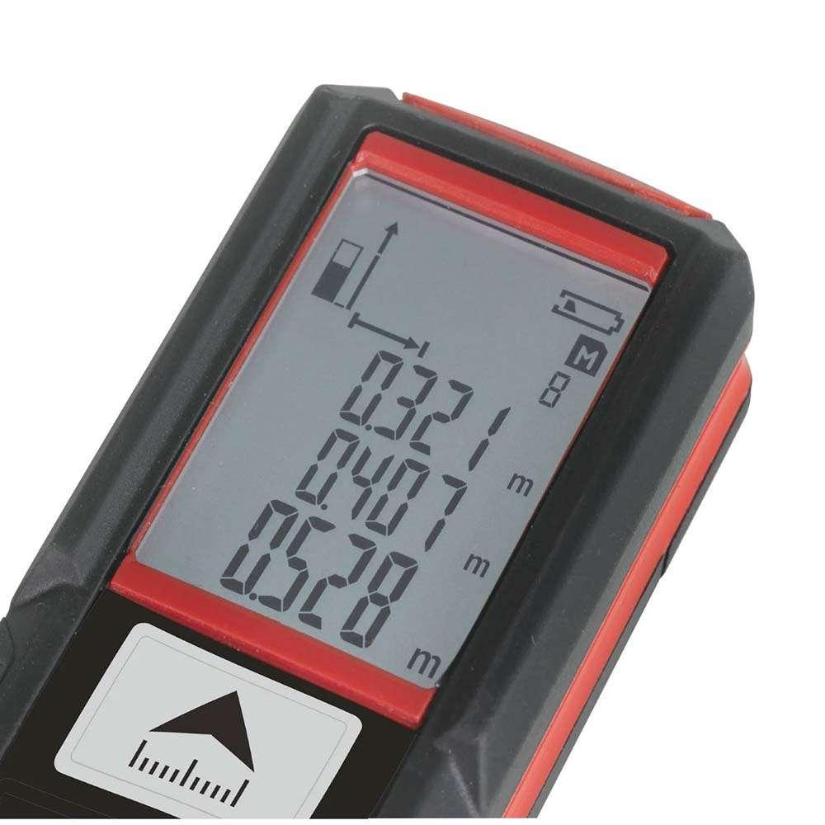
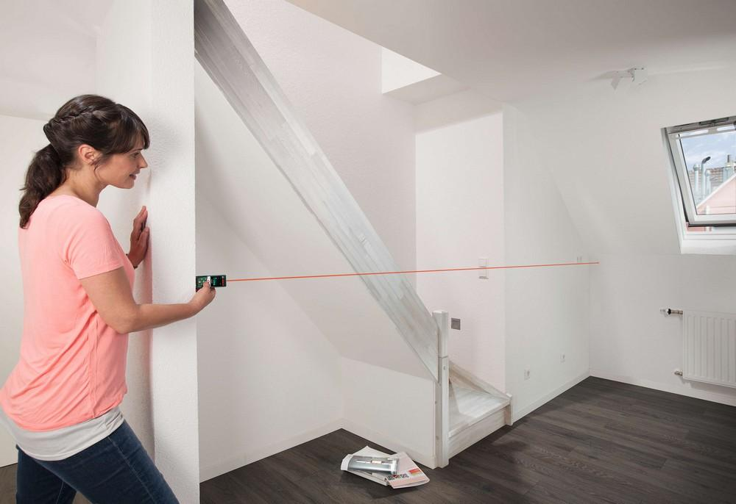
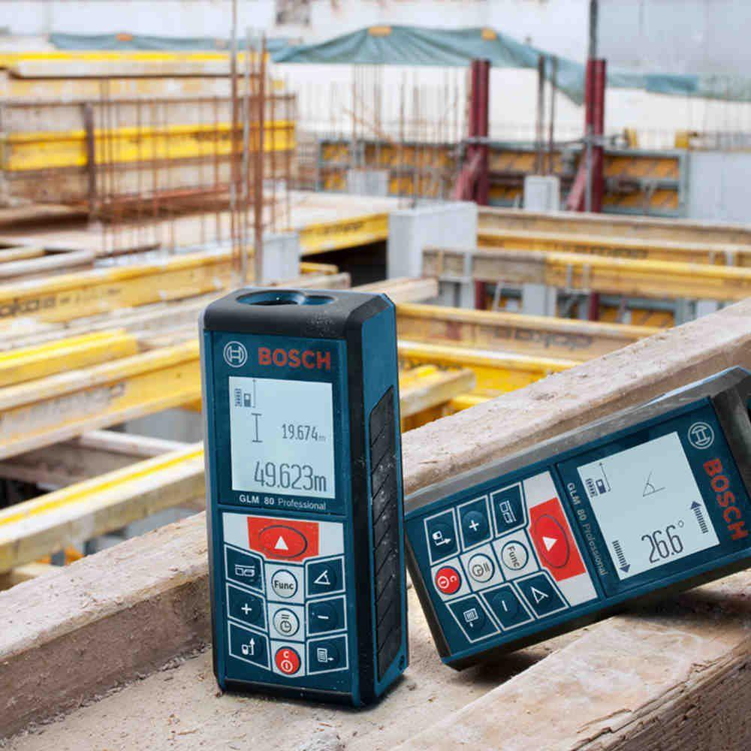
A Laser Distance Meter (also called a Laser Distance Measurer or Laser Rangefinder) is an electronic measuring instrument that uses a laser beam to accurately measure the distance between the instrument and a target. It provides fast, precise, and non-contact measurements over much longer distances than a ruler, measuring tape, or Vernier caliper.
Laser distance meters are widely used in construction, architecture, engineering, surveying, interior design, real estate, manufacturing, and facility management.

Definition
# Source: AI Source: Provided by: [Data Path: Persons Table -> ID Column: 1, Name_En Column: Motasem Essam] -> From: [ChatGPT] on [7/17/2026]
A Laser Distance Meter is an electronic measuring instrument that uses laser technology to determine the distance between the instrument and a target by measuring the time or phase of the reflected laser beam.

Purpose
# Source: AI Source: Provided by: [Data Path: Persons Table -> ID Column: 1, Name_En Column: Motasem Essam] -> From: [ChatGPT] on [7/17/2026]
A Laser Distance Meter is used to:
- Measure long distances.
- Measure room dimensions.
- Measure building heights.
- Measure widths.
- Measure inaccessible locations.
- Calculate area and volume.
- Perform indirect height measurements.
- Support construction layout work.

Principle of Operation
# Source: AI Source: Provided by: [Data Path: Persons Table -> ID Column: 1, Name_En Column: Motasem Essam] -> From: [ChatGPT] on [7/17/2026]
A Laser Distance Meter emits a laser beam toward a target.
The beam reflects back from the target, and the instrument calculates the distance using one of two methods:
- Time-of-Flight (ToF): Measures the time taken for the laser pulse to travel to the target and back.
- Phase Shift Measurement: Compares the phase difference between the emitted and reflected laser waves for very high accuracy.
The calculated distance is displayed instantly on the screen.

Main Components
# Source: AI Source: Provided by: [Data Path: Persons Table -> ID Column: 1, Name_En Column: Motasem Essam] -> From: [ChatGPT] on [7/17/2026]
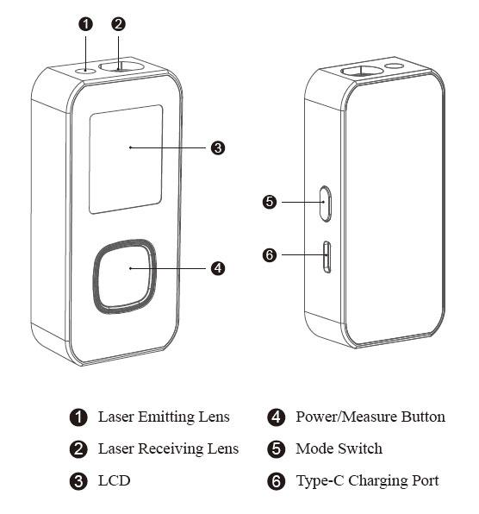
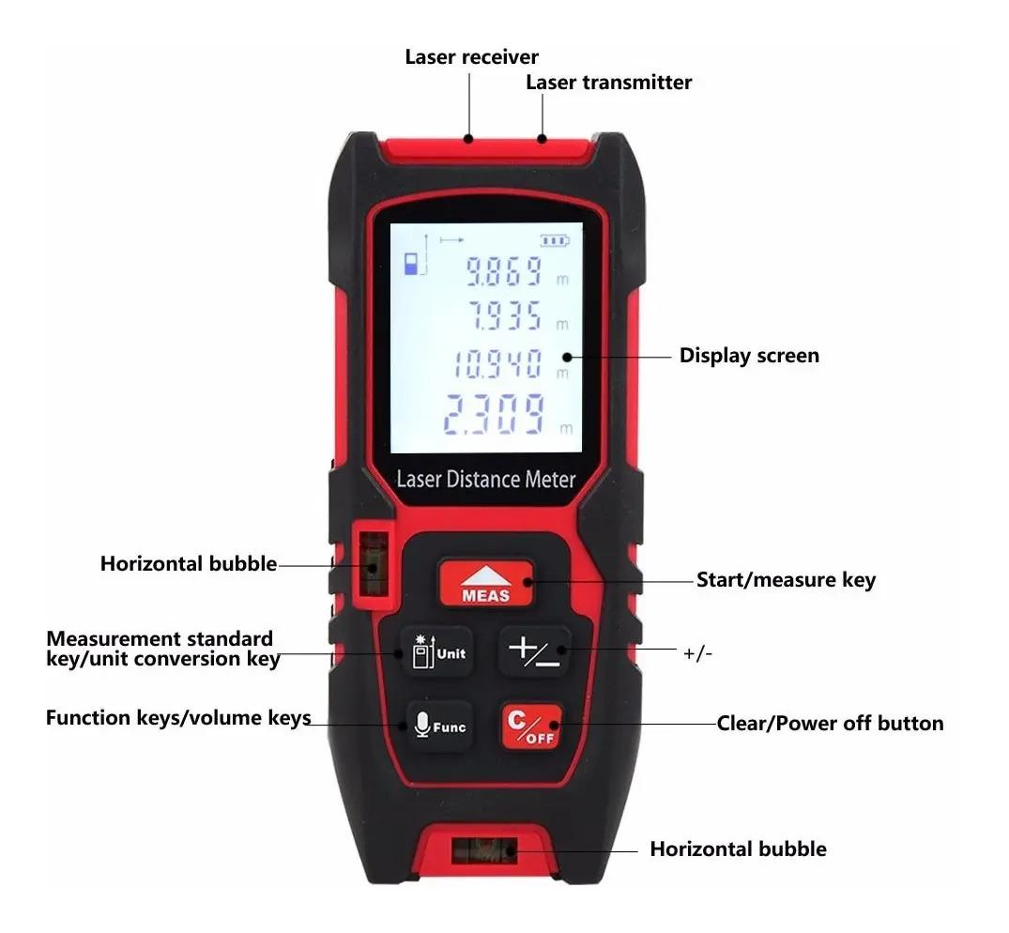
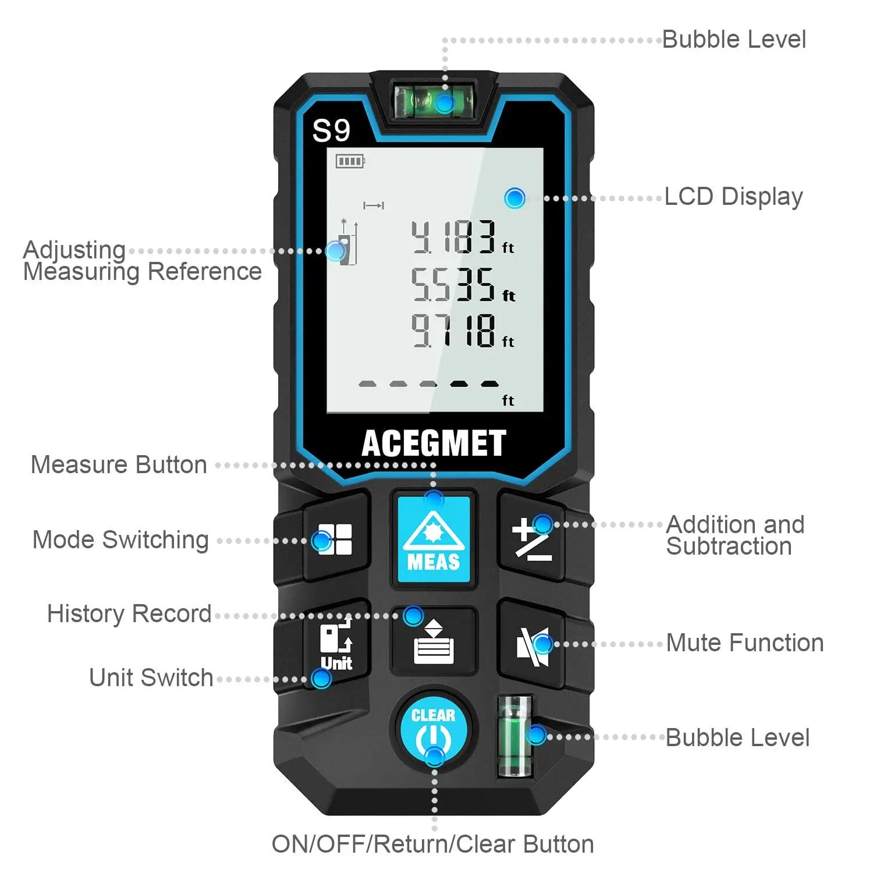
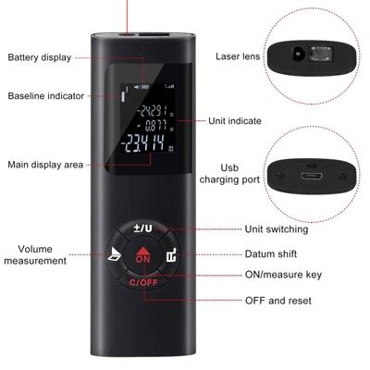
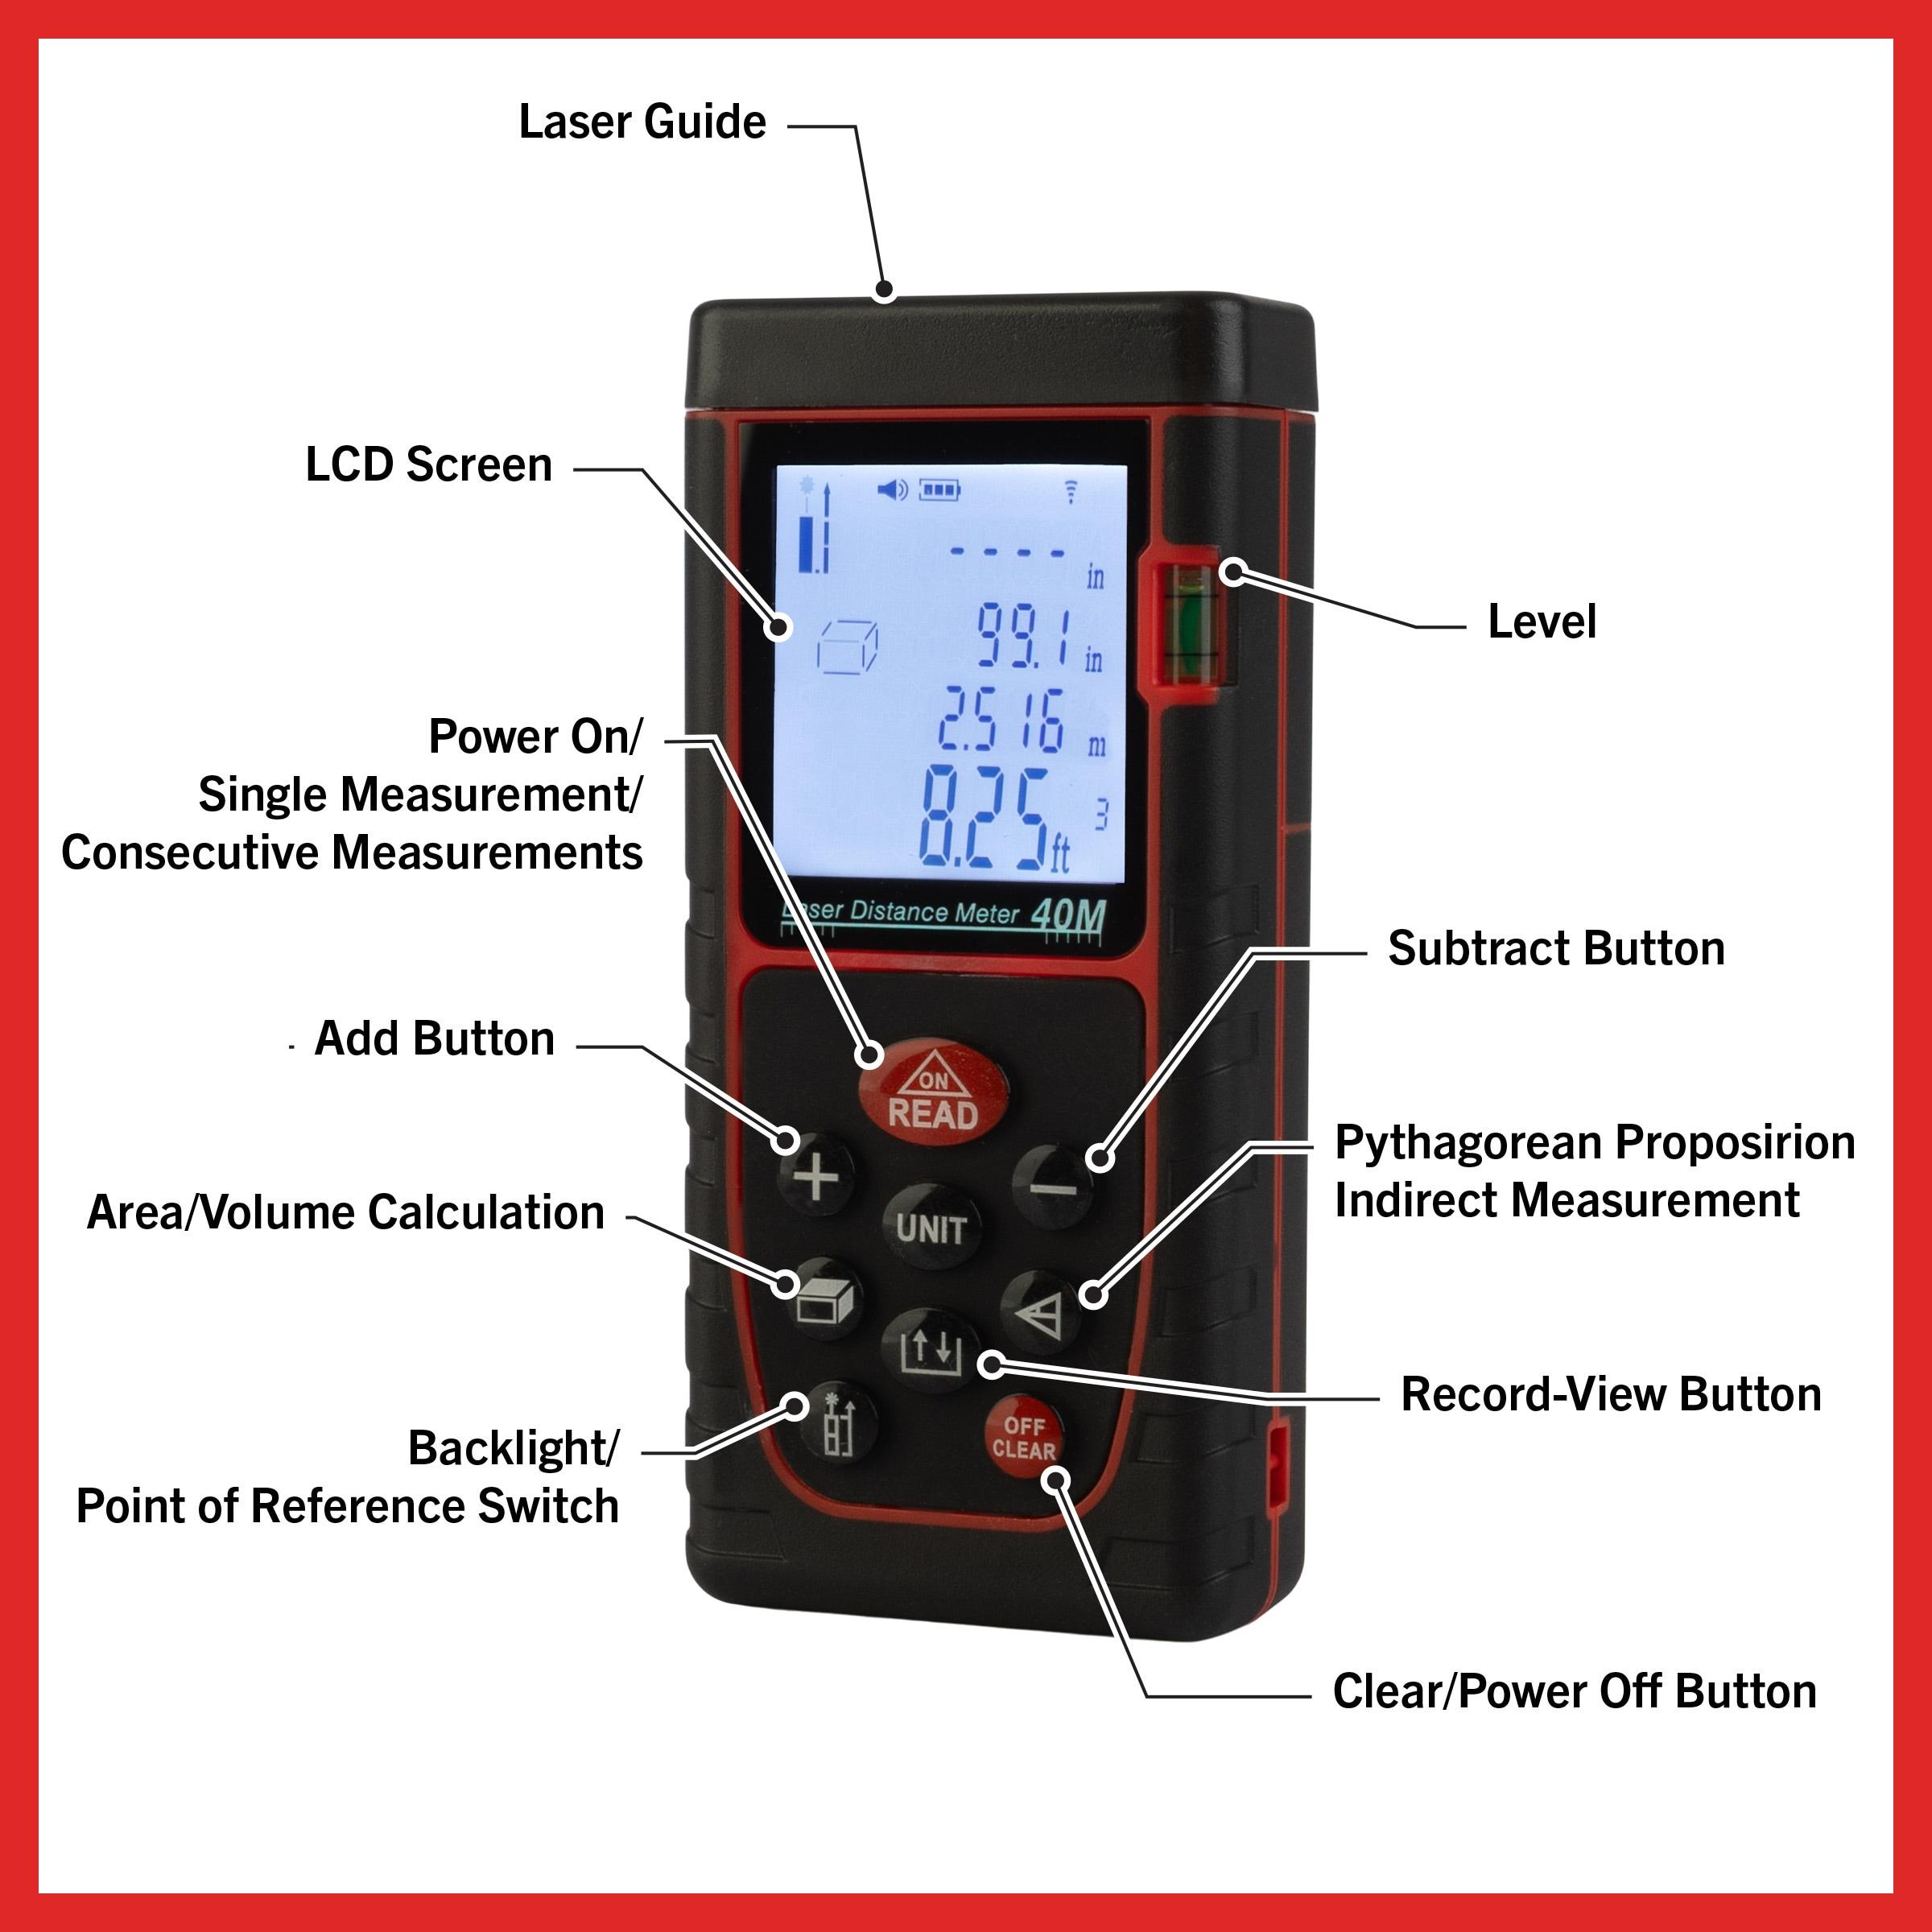
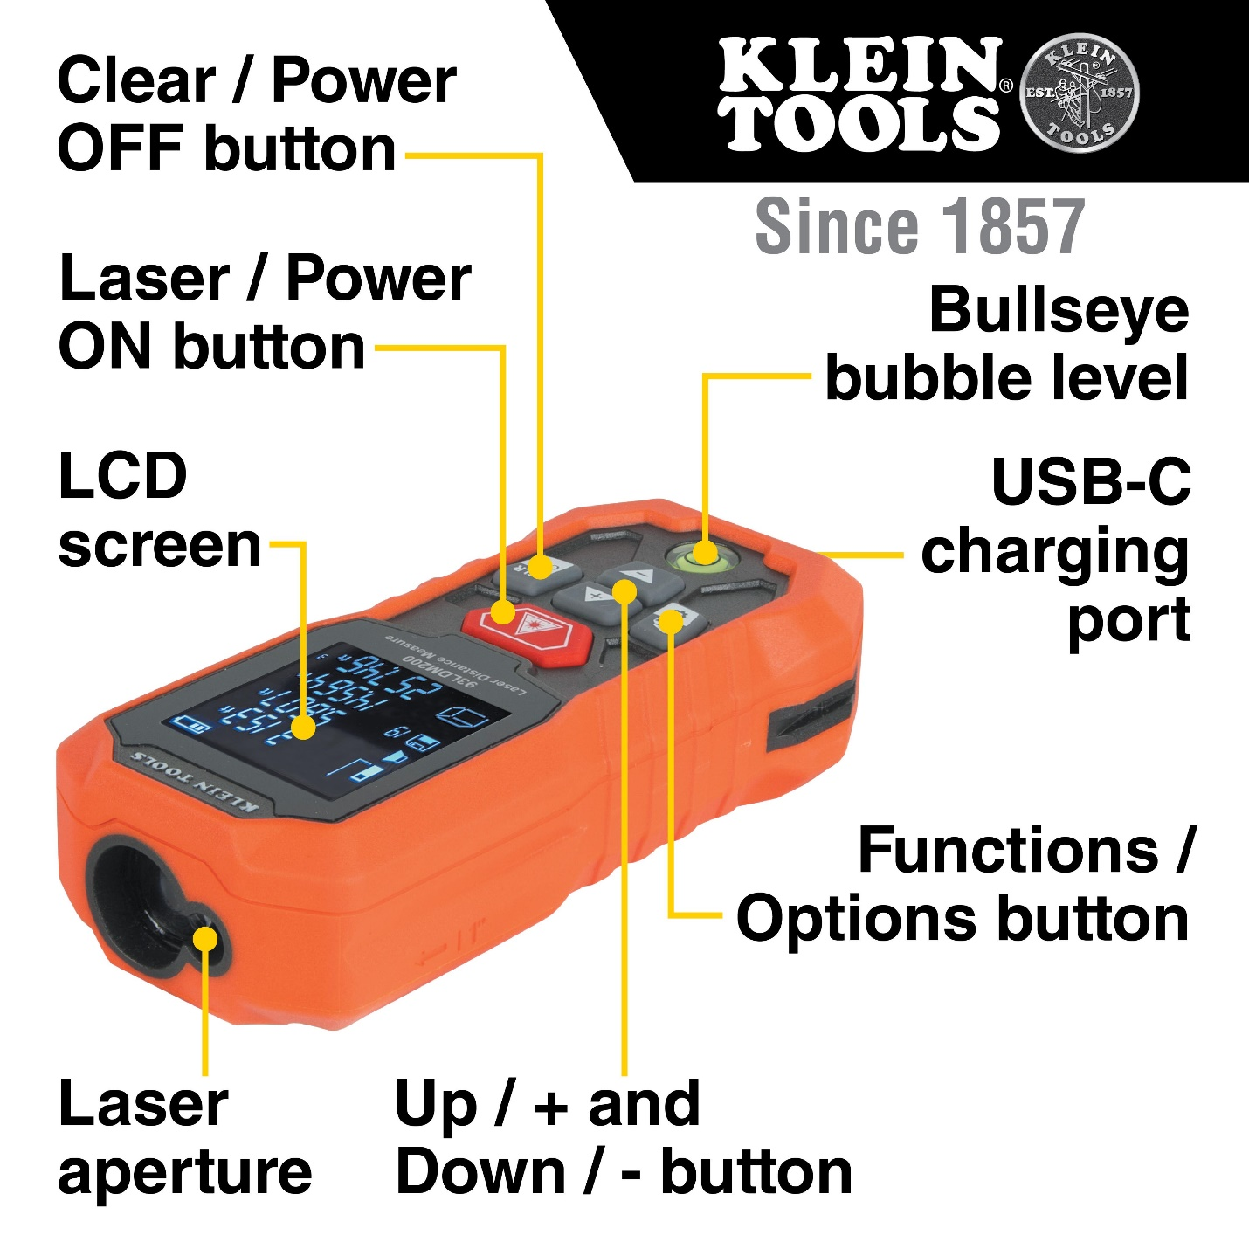
A typical Laser Distance Meter consists of:
- Laser Emitter
- Laser Receiver (Sensor)
- LCD Display
- Control Buttons
- Processor
- Battery Compartment
- Reference Point Selector (front or rear)
- Housing

Types of Laser Distance Meters

1. Basic Laser Distance Meter
# Source: AI Source: Provided by: [Data Path: Persons Table -> ID Column: 1, Name_En Column: Motasem Essam] -> From: [ChatGPT] on [7/17/2026]
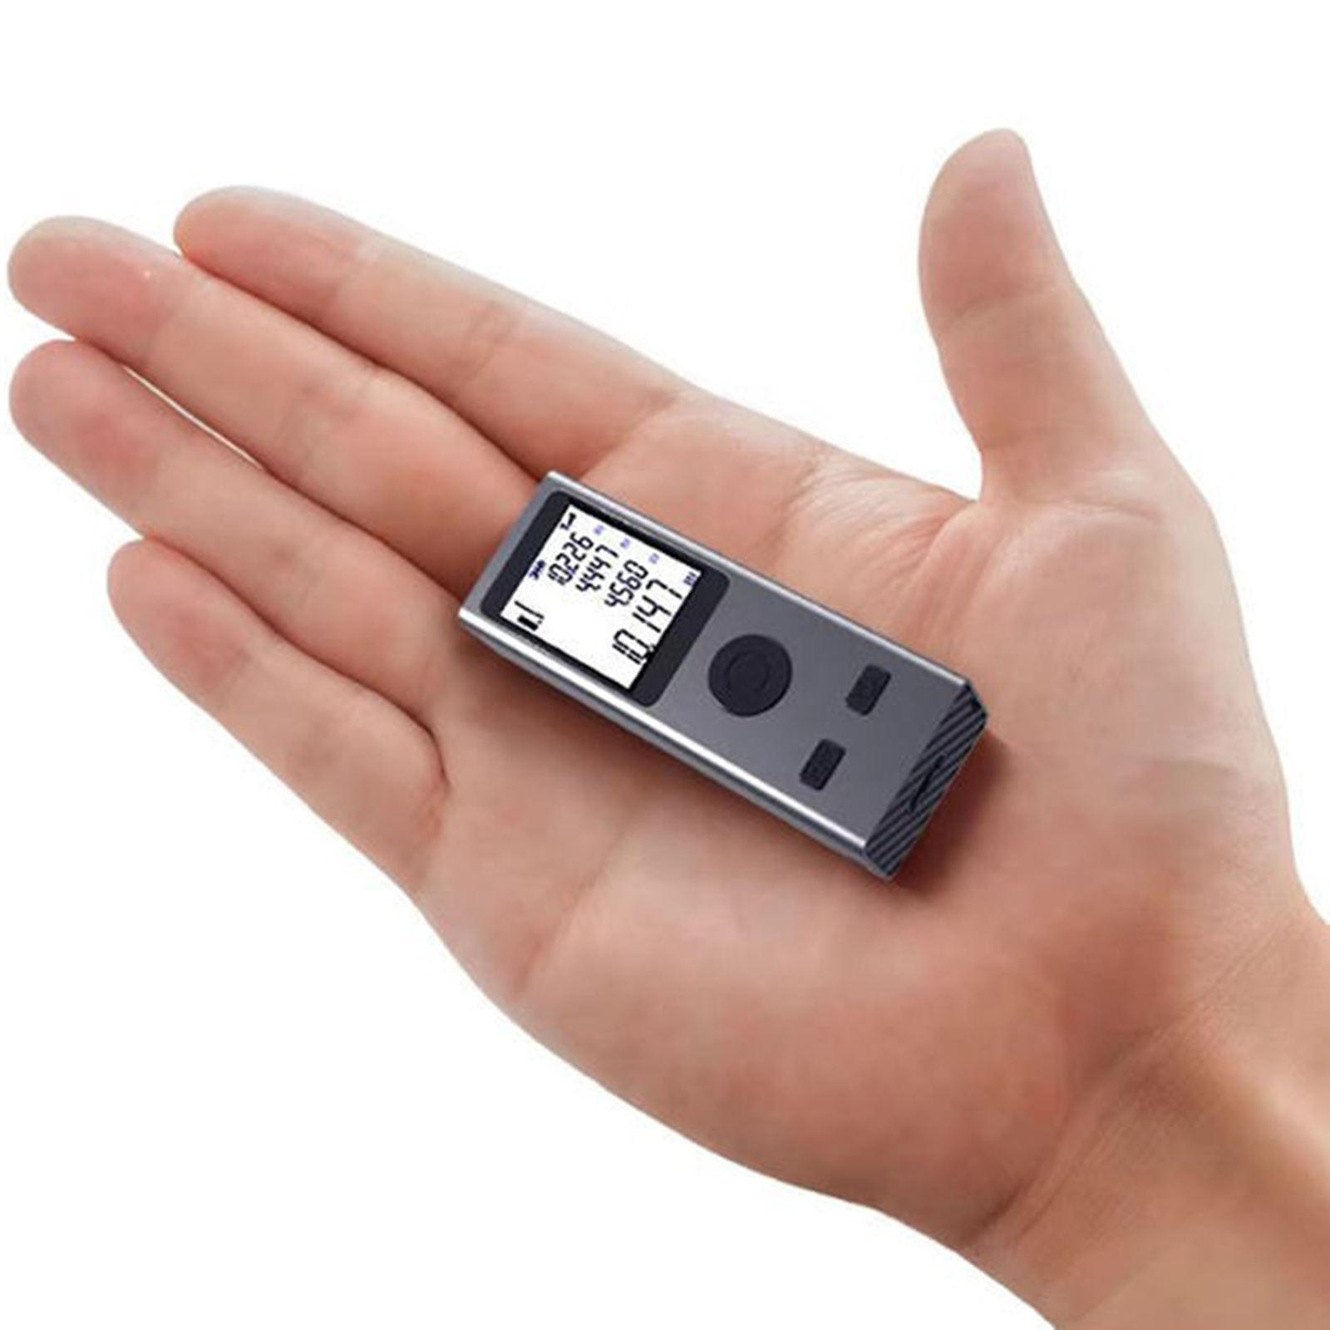
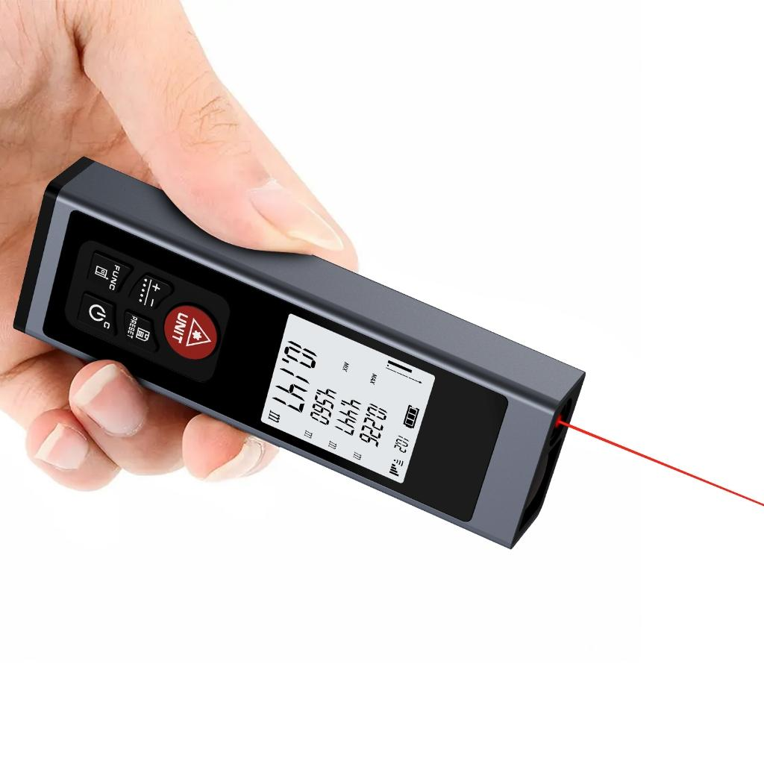
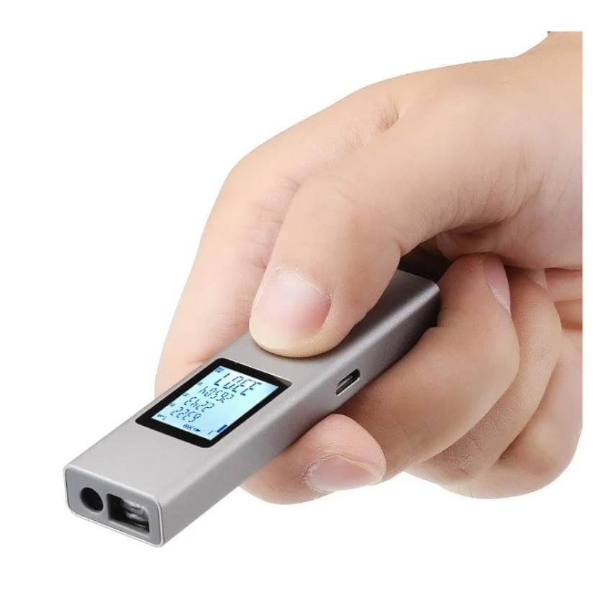
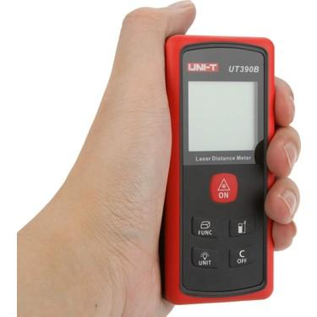
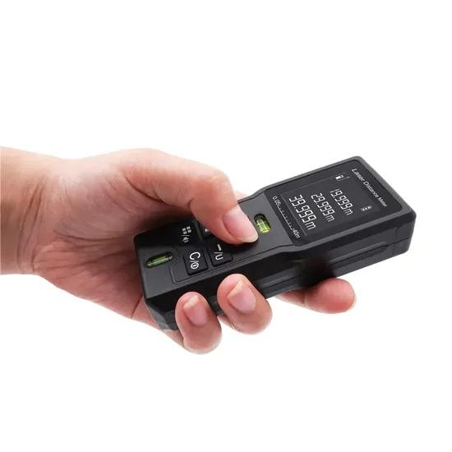
Description
A Basic Laser Distance Meter is designed for straightforward distance measurements. It provides quick, accurate linear distance readings and is ideal for everyday indoor measuring tasks.
Features
- Compact handheld design
- Single distance measurement
- LCD display
- Metric and/or imperial units
- Simple button controls
Typical Measuring Range
- 0.05–40 m
Applications
- Home improvement
- Furniture placement
- Interior decoration
- DIY projects
- Small office measurements

2. Advanced Laser Distance Meter
# Source: AI Source: Provided by: [Data Path: Persons Table -> ID Column: 1, Name_En Column: Motasem Essam] -> From: [ChatGPT] on [7/17/2026]
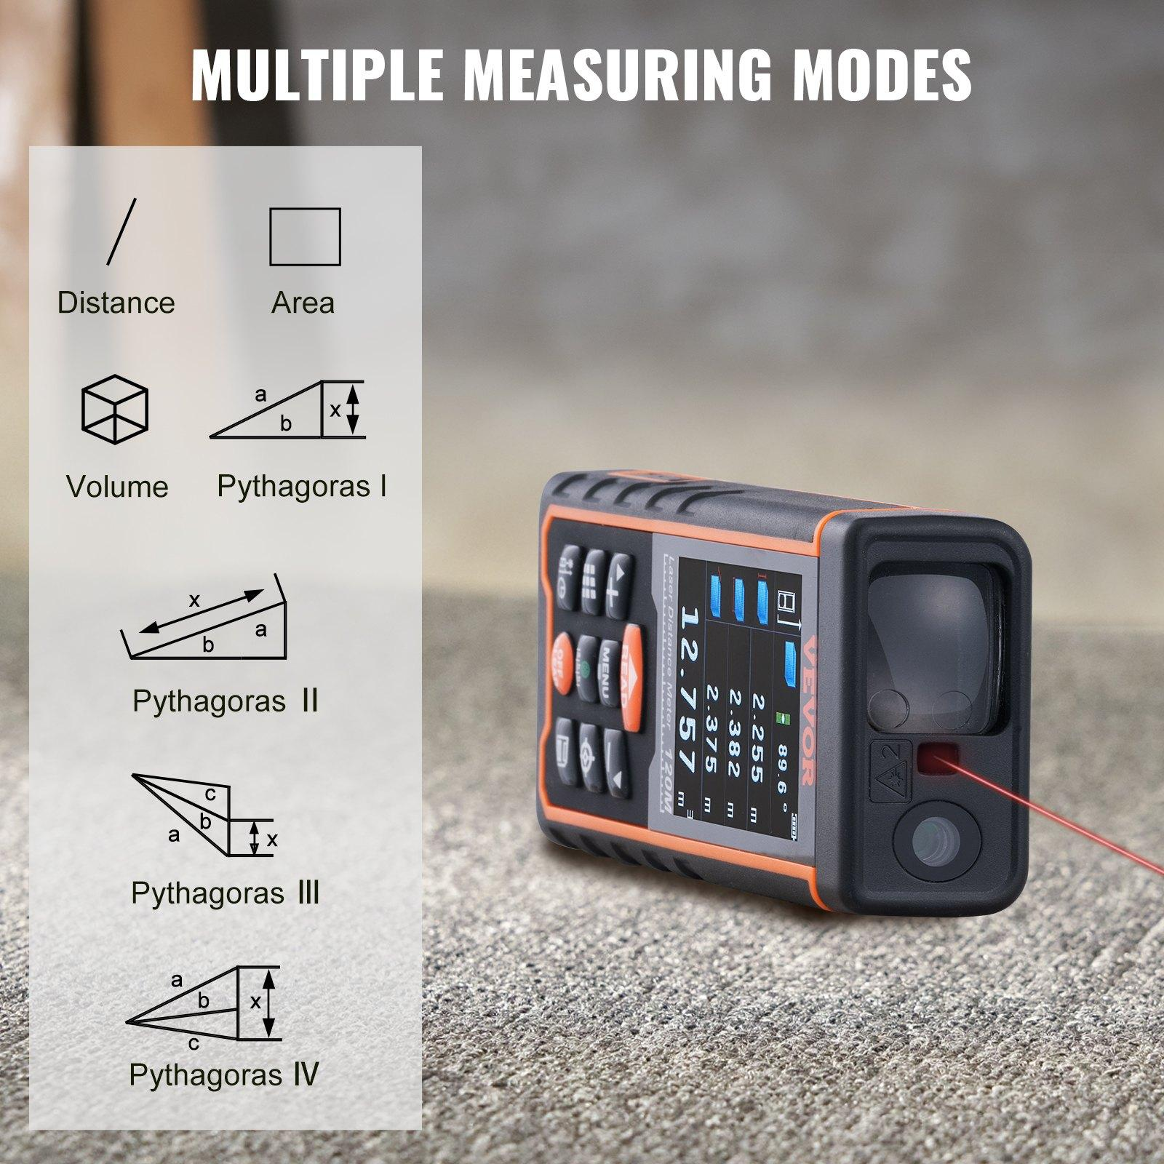
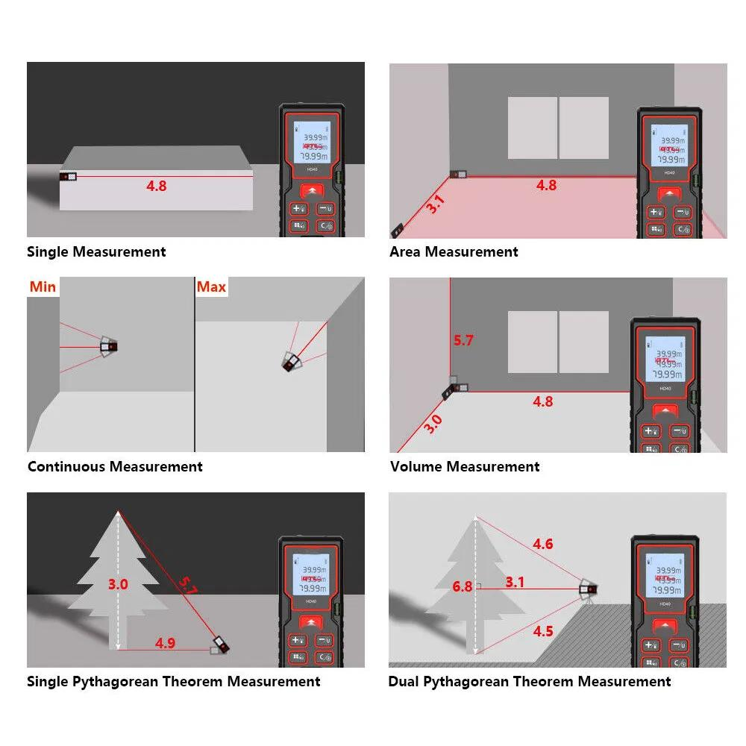
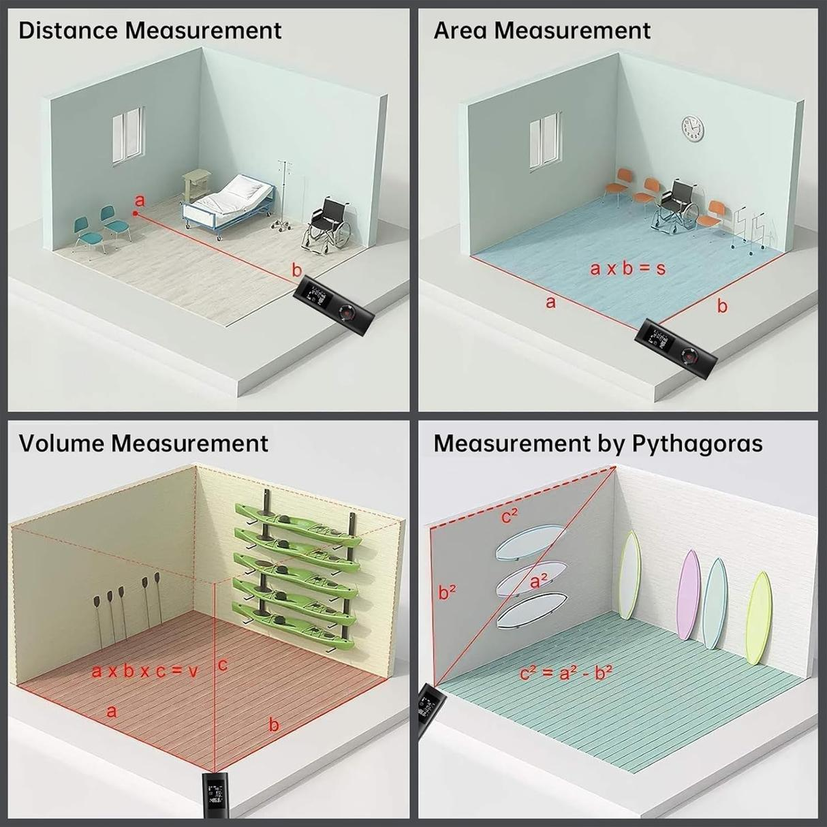
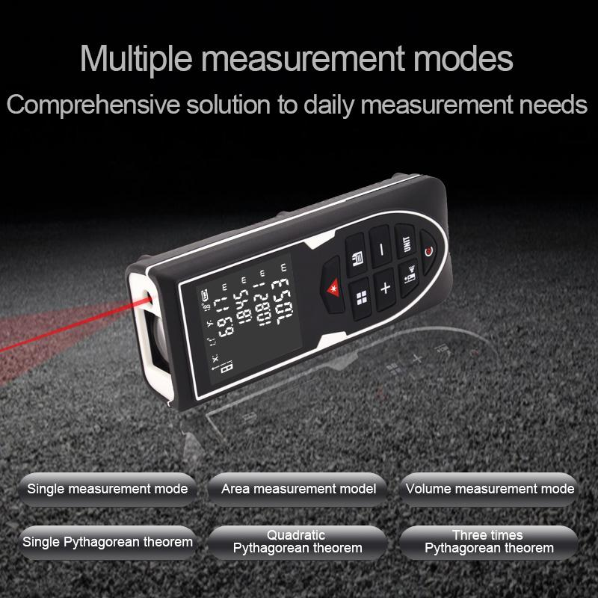
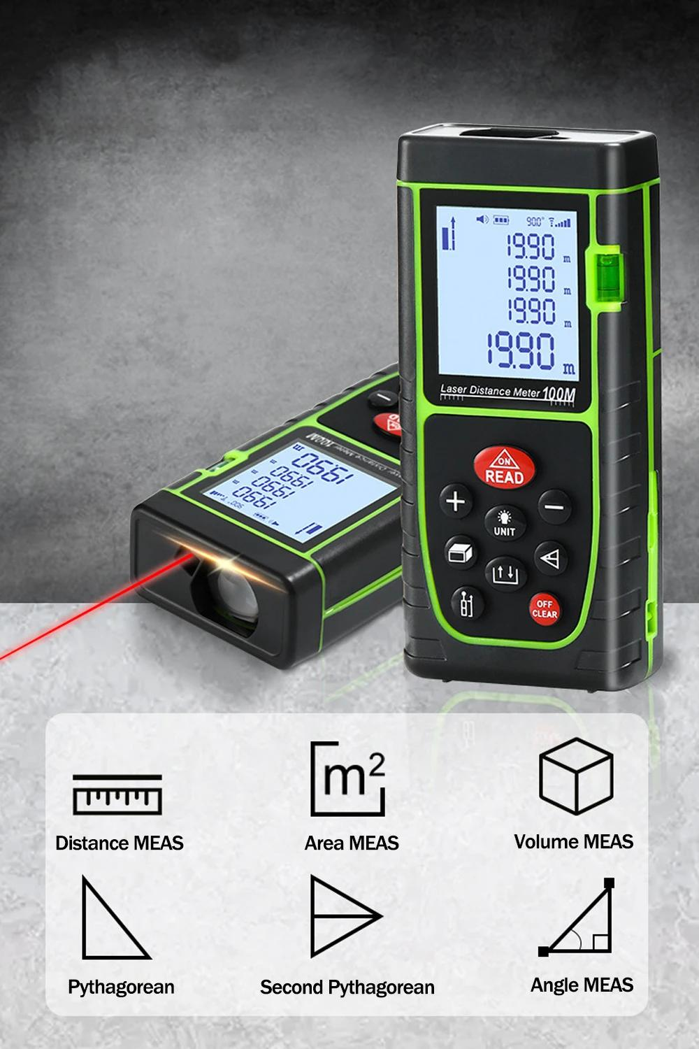
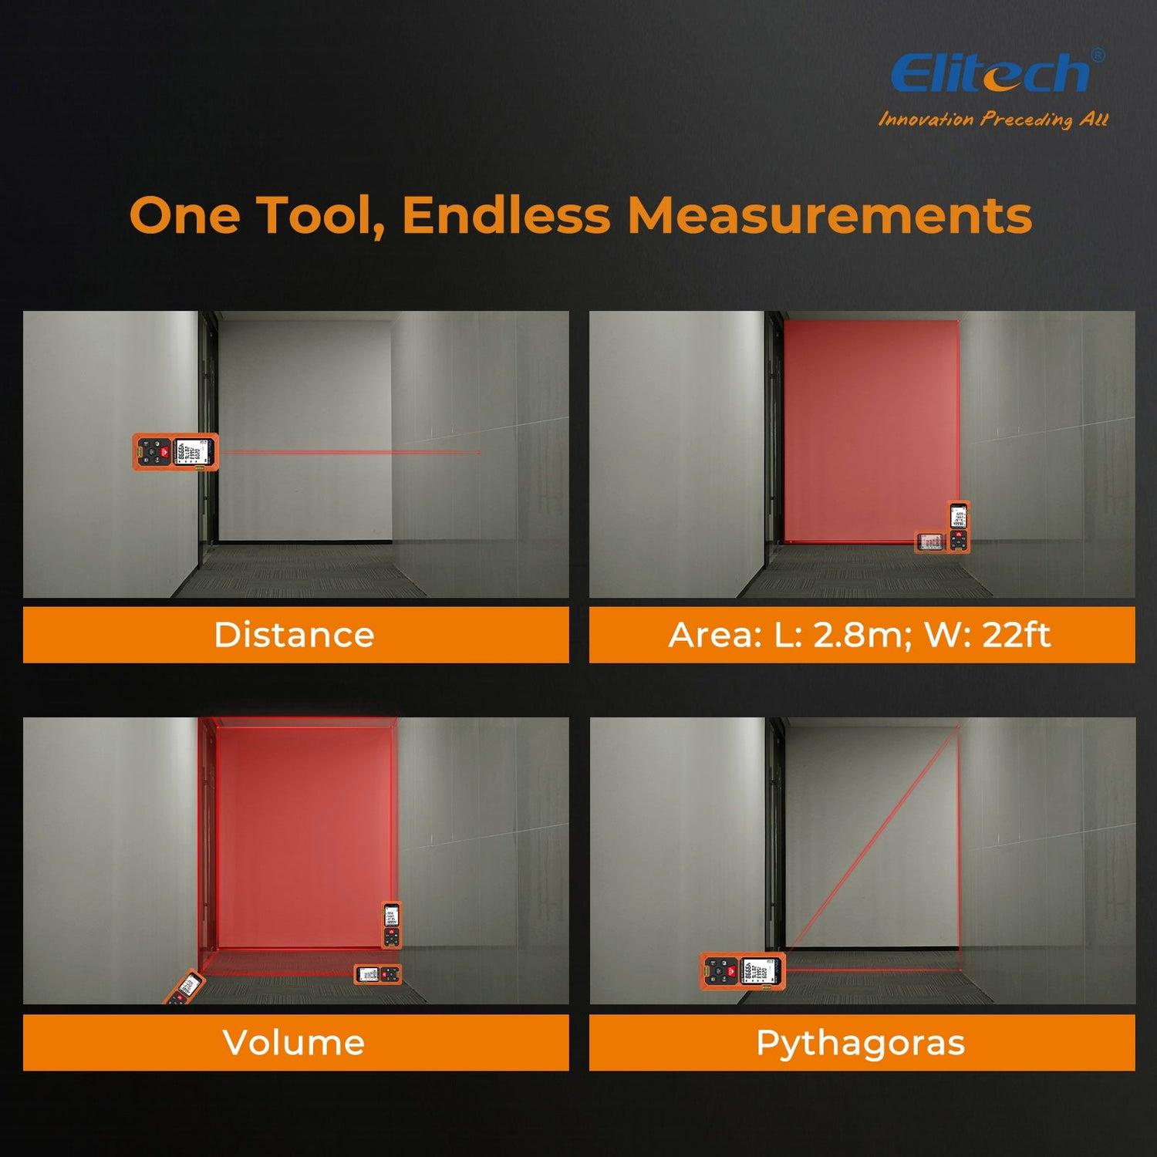
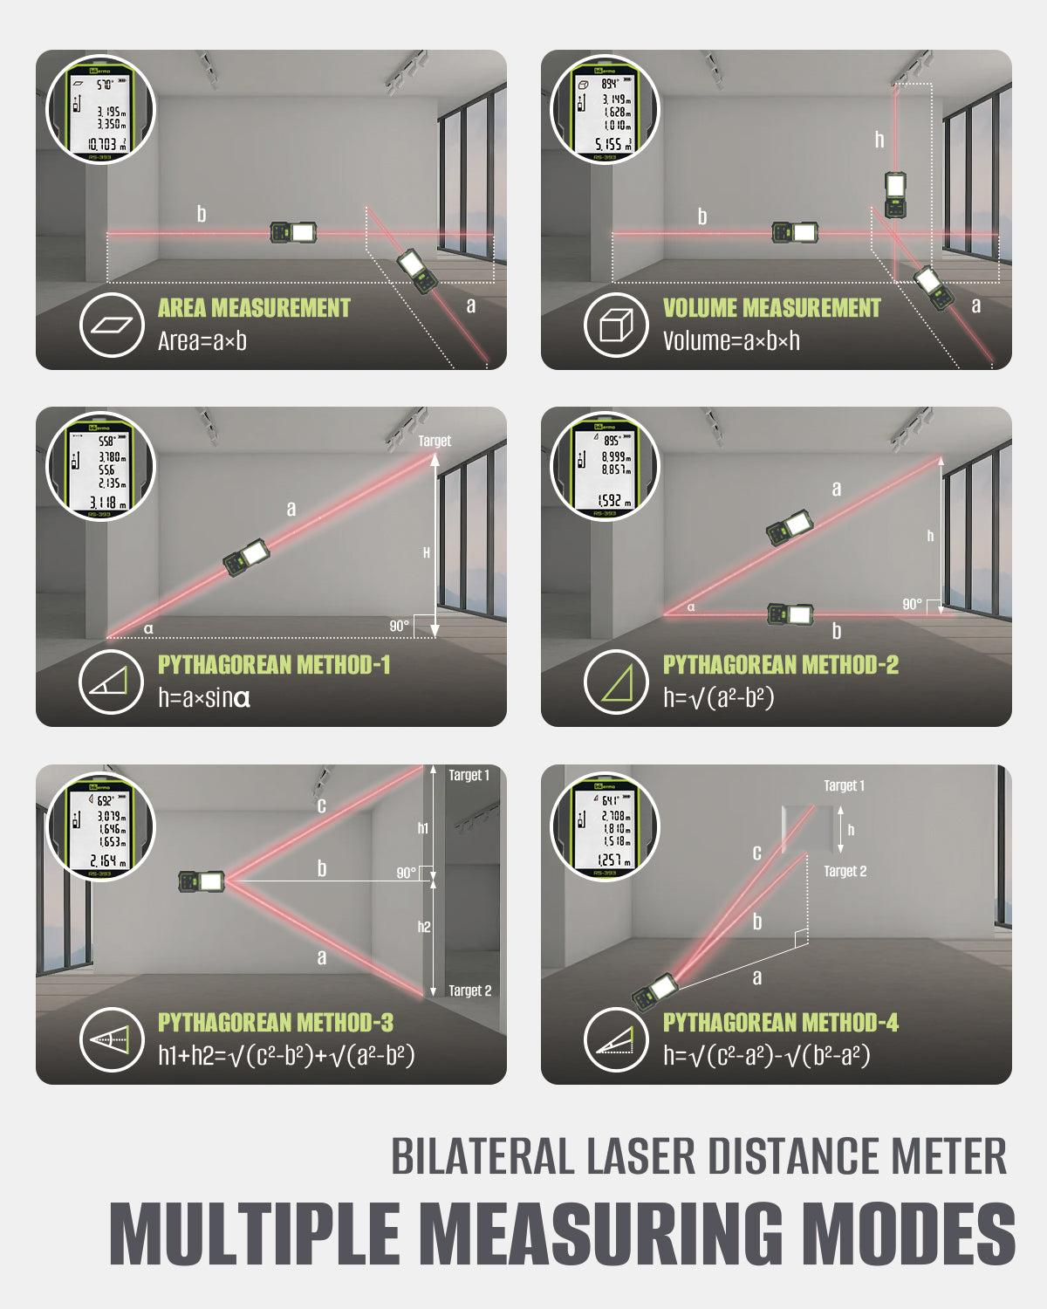
Description
An Advanced Laser Distance Meter offers additional measurement modes beyond simple distance, including automatic calculations for area, volume, and indirect height using the Pythagorean theorem.
Features
- Distance measurement
- Area calculation
- Volume calculation
- Indirect height measurement
- Measurement memory
- Continuous measurement mode
Typical Measuring Range
- 0.05–100 m
Applications
- Construction
- Architecture
- Civil engineering
- Interior design
- Building inspection

3. Outdoor Laser Distance Meter
# Source: AI Source: Provided by: [Data Path: Persons Table -> ID Column: 1, Name_En Column: Motasem Essam] -> From: [ChatGPT] on [7/17/2026]
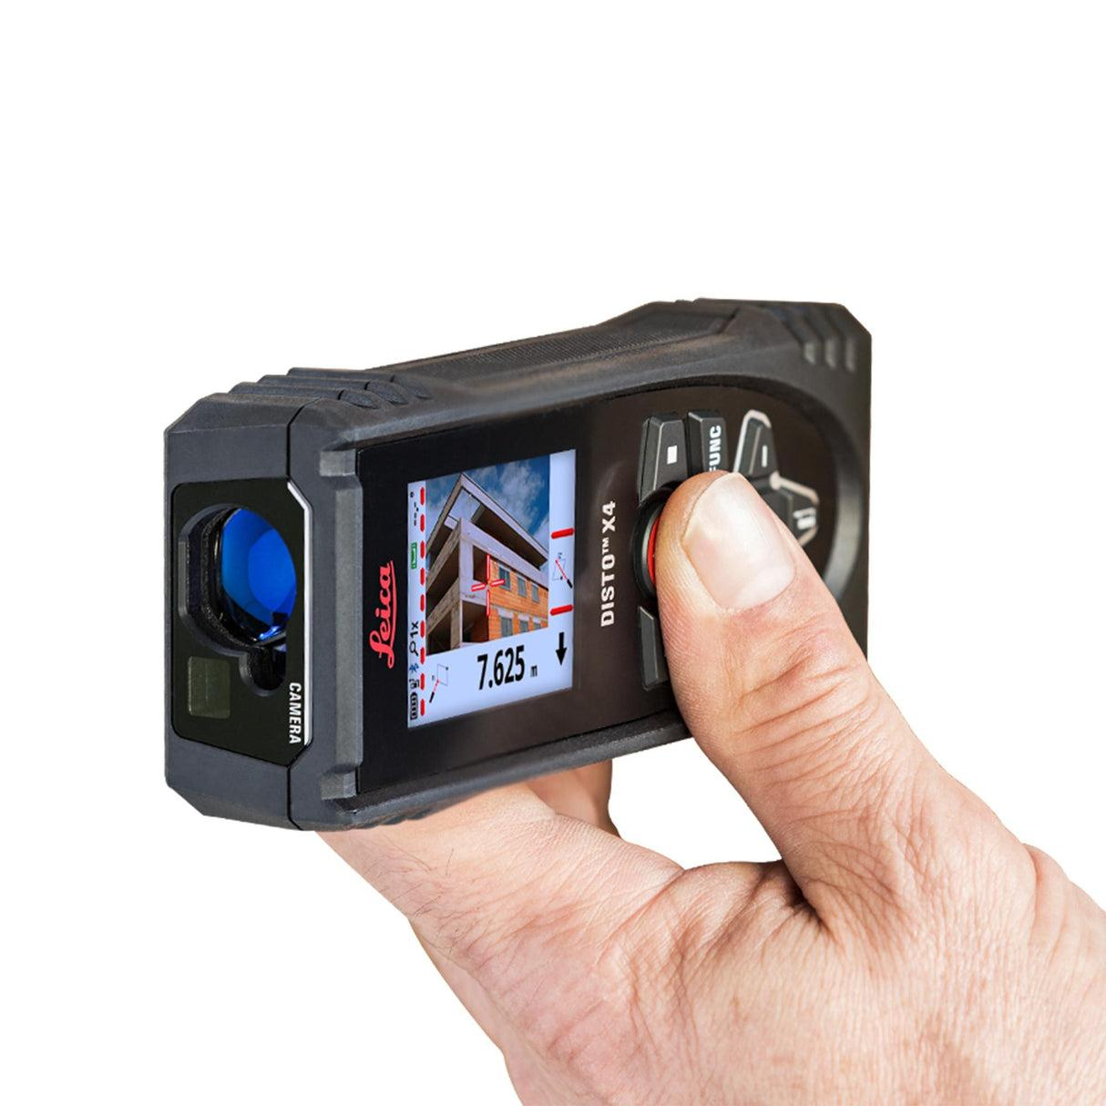
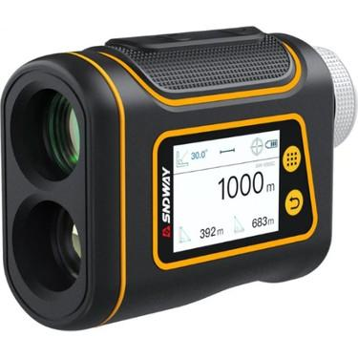
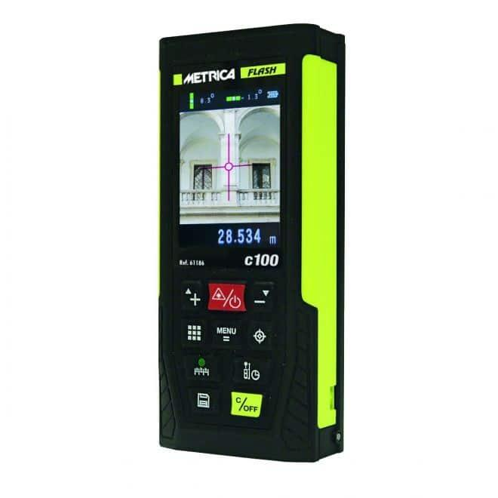
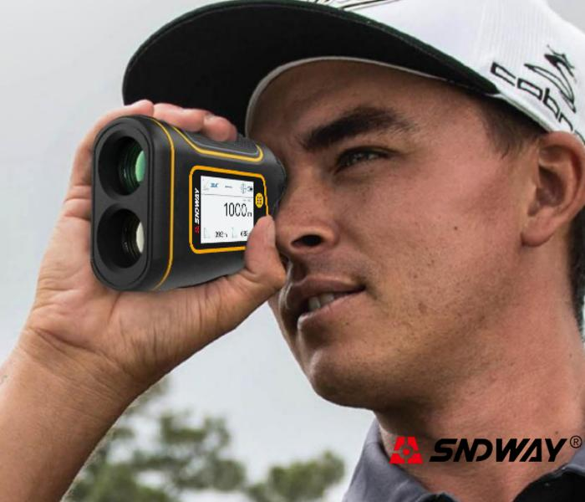
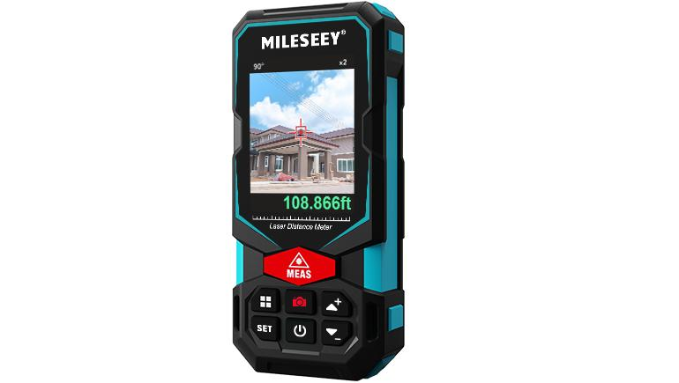
Description
An Outdoor Laser Distance Meter is designed for long-range measurements in bright outdoor environments. Many models include an optical or digital viewfinder to improve target visibility.
Features
- High-power laser
- Long measuring range
- Optical/digital viewfinder
- Bright sunlight visibility
- Rugged weather-resistant housing
Typical Measuring Range
- 100–200 m or more
Applications
- Surveying
- Civil engineering
- Road construction
- Land measurement
- Outdoor construction

4. Bluetooth / Smart Laser Distance Meter
# Source: AI Source: Provided by: [Data Path: Persons Table -> ID Column: 1, Name_En Column: Motasem Essam] -> From: [ChatGPT] on [7/17/2026]
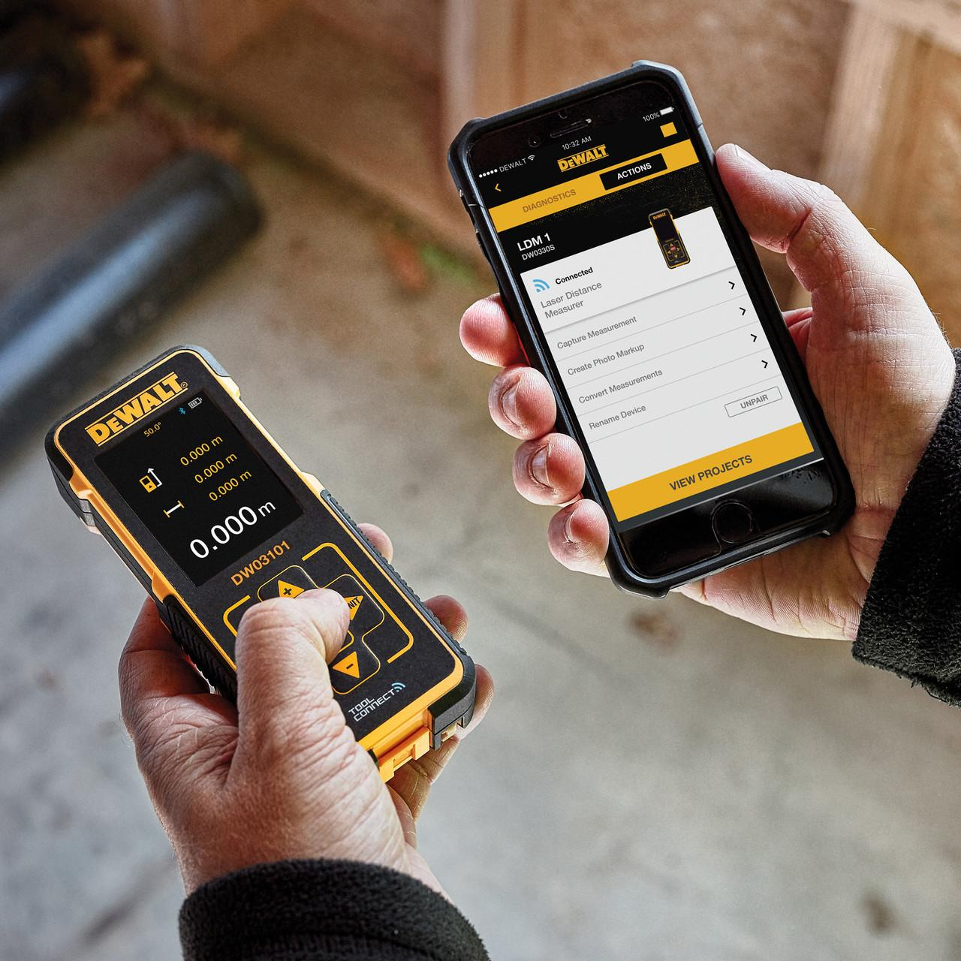
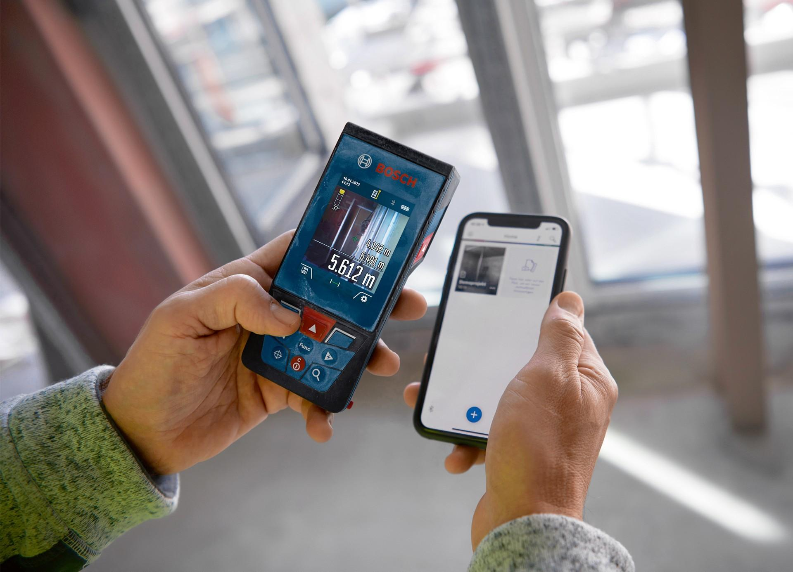
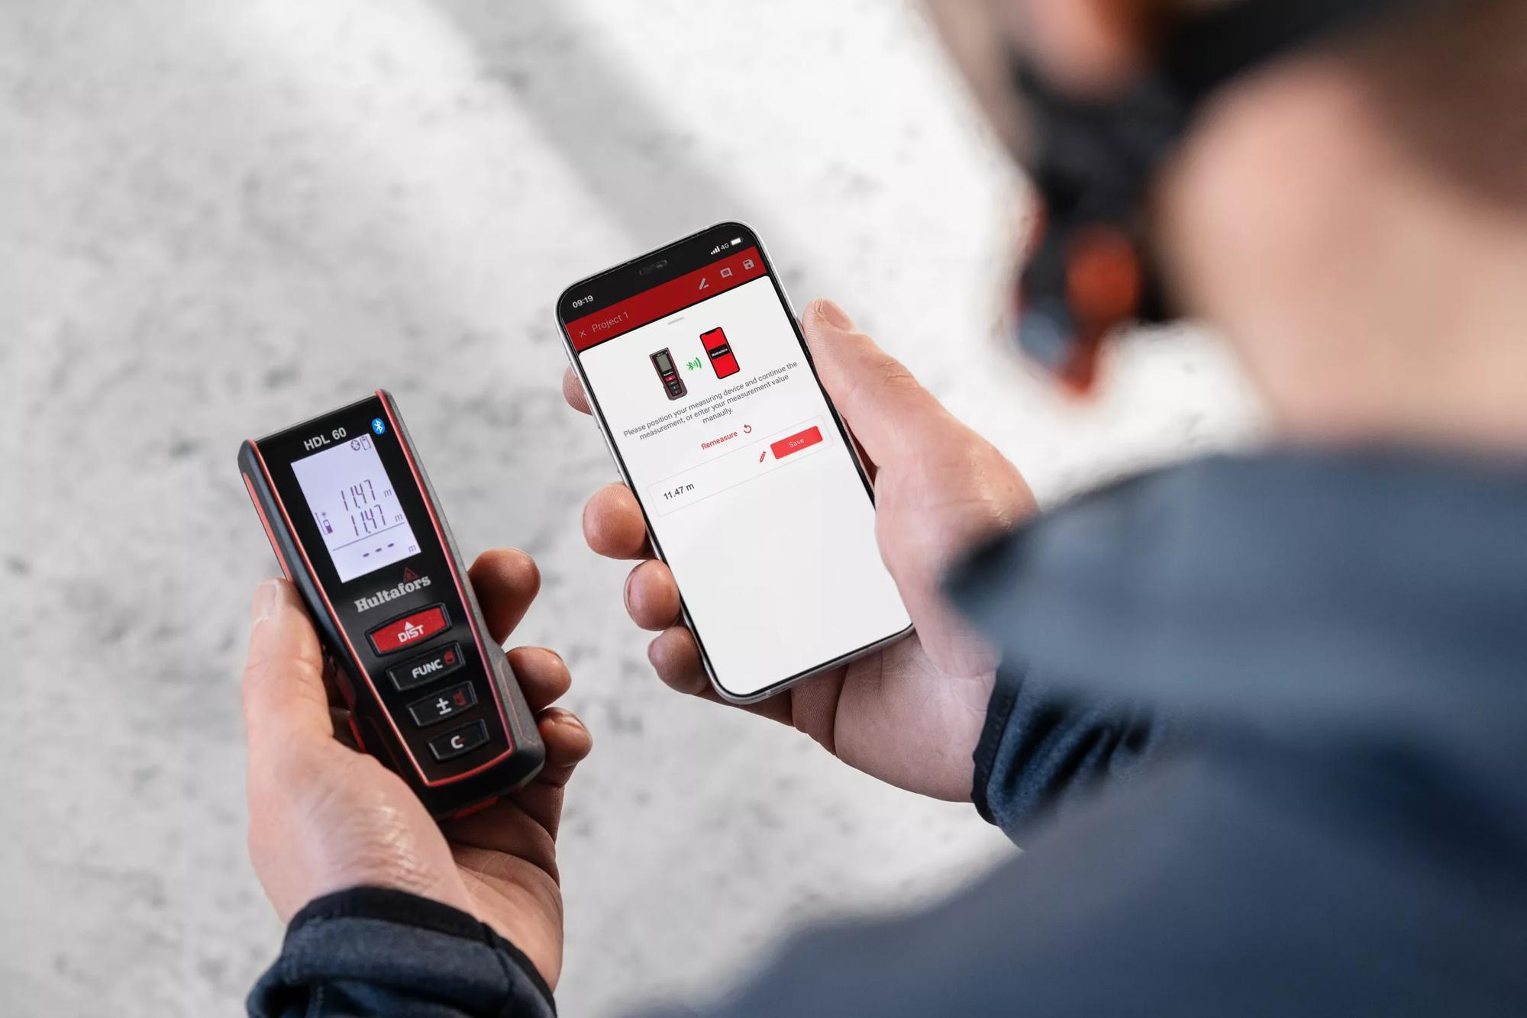
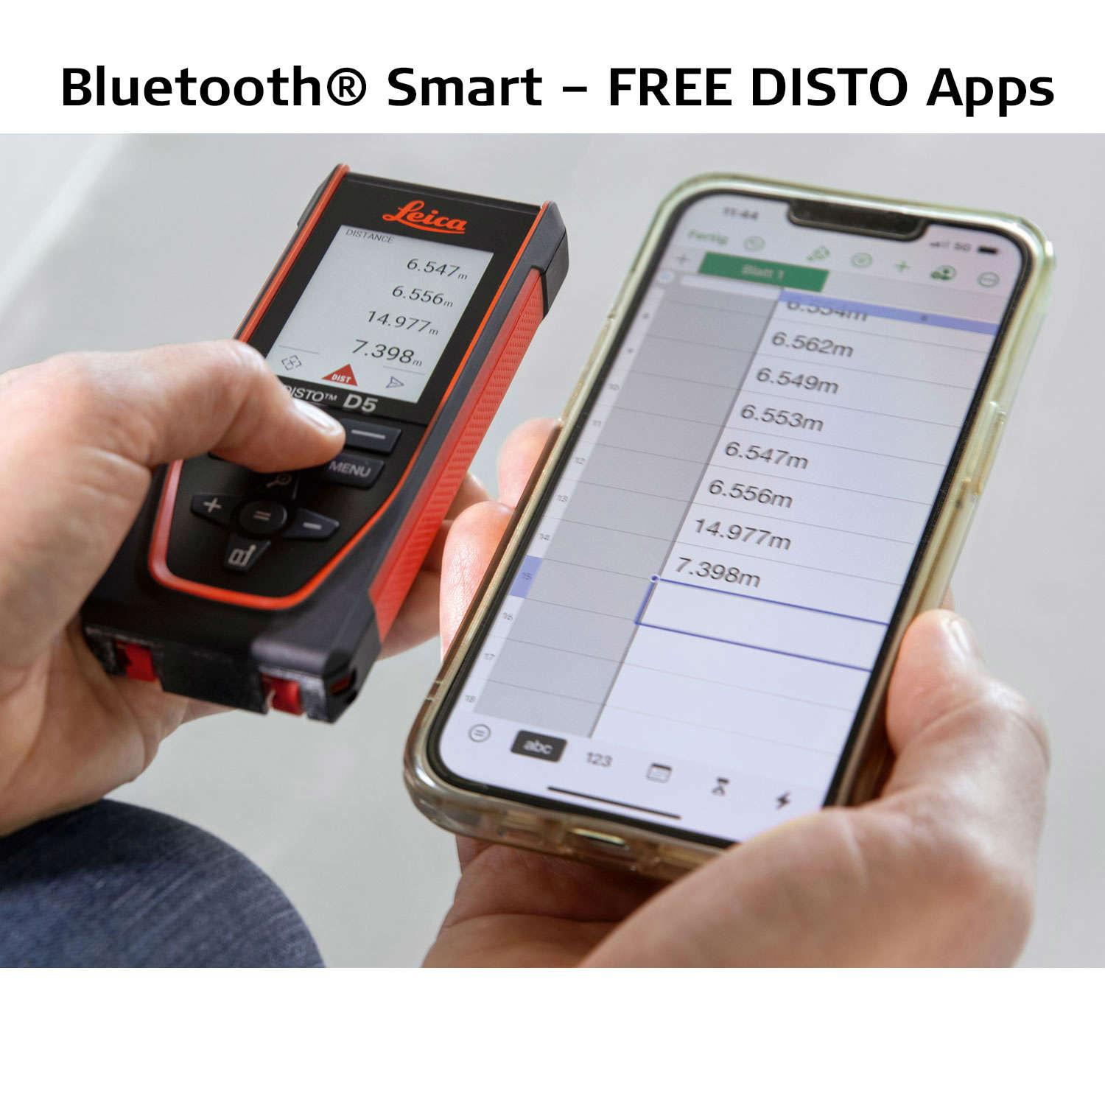
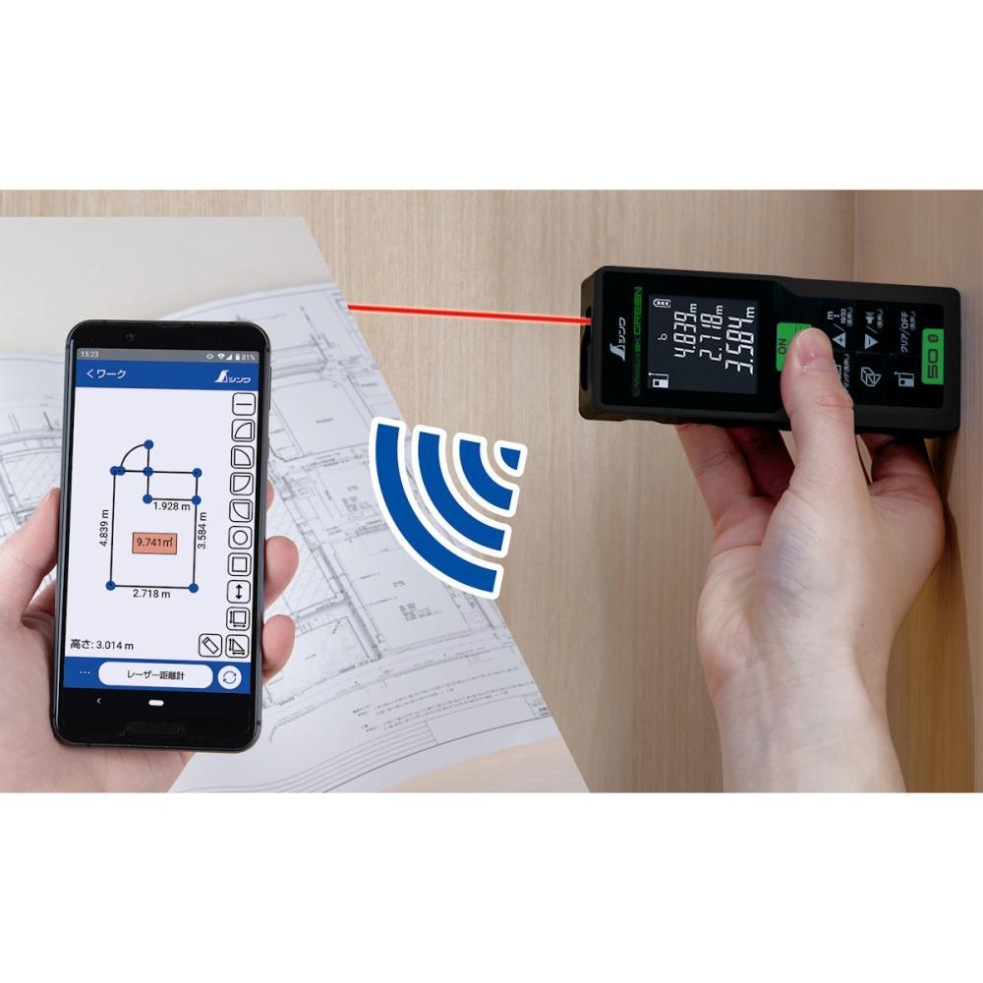
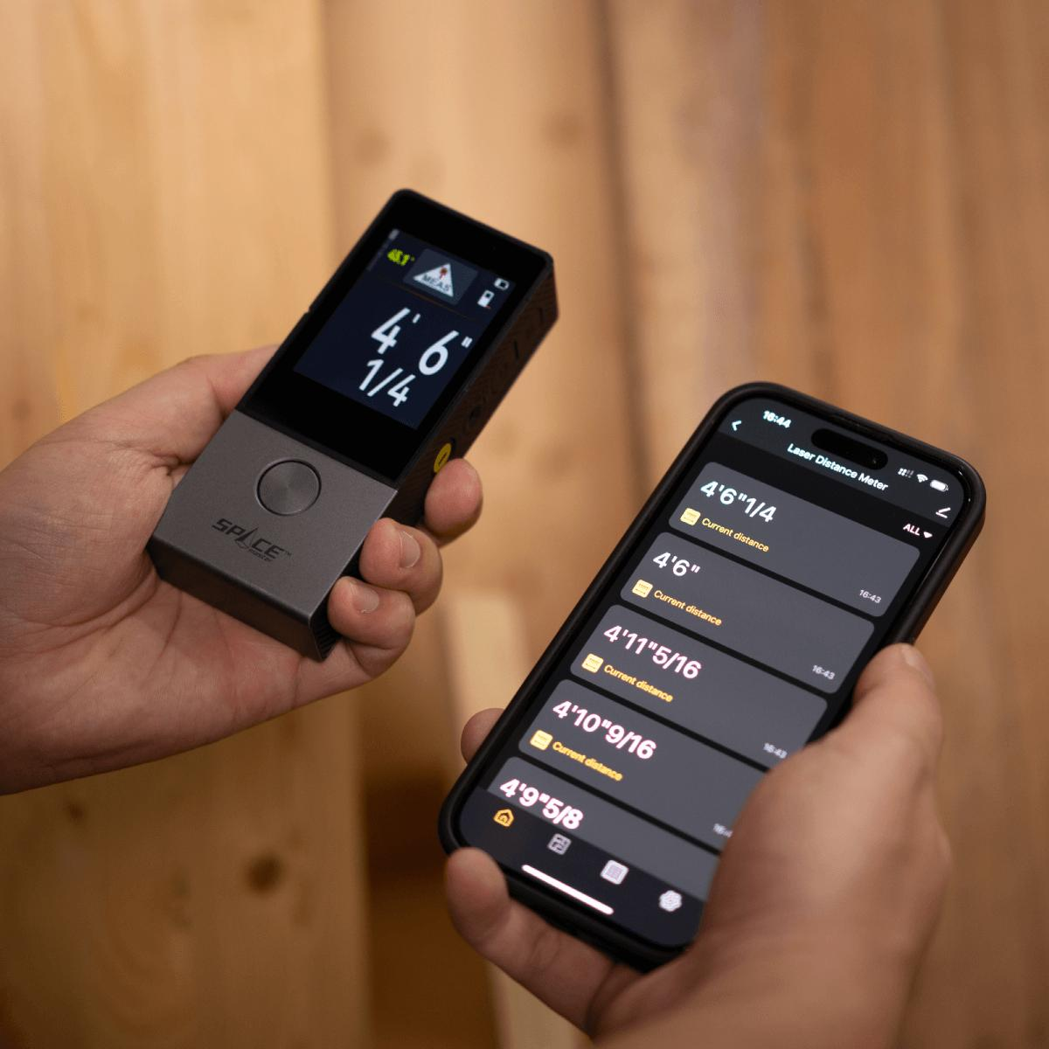
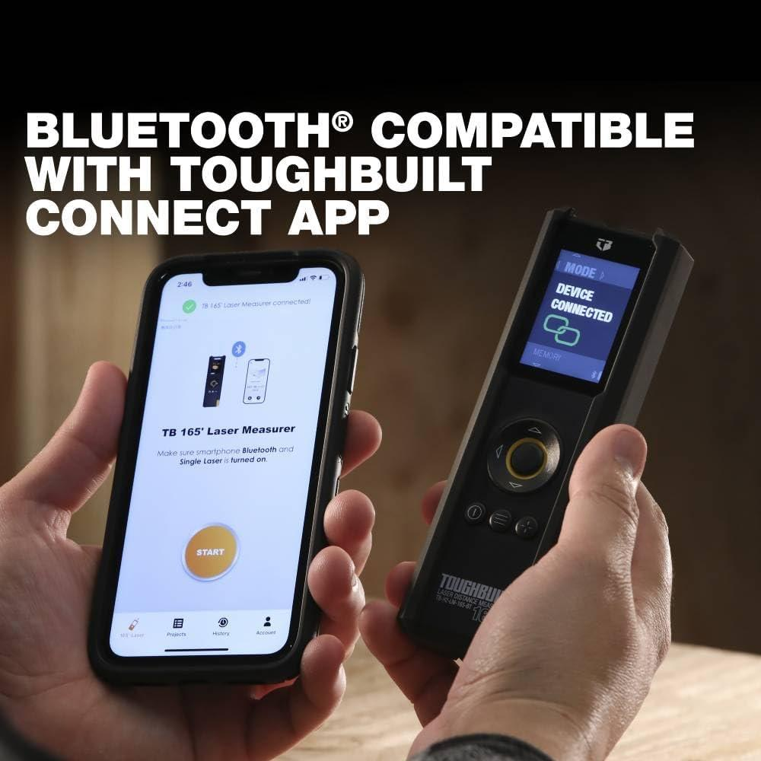
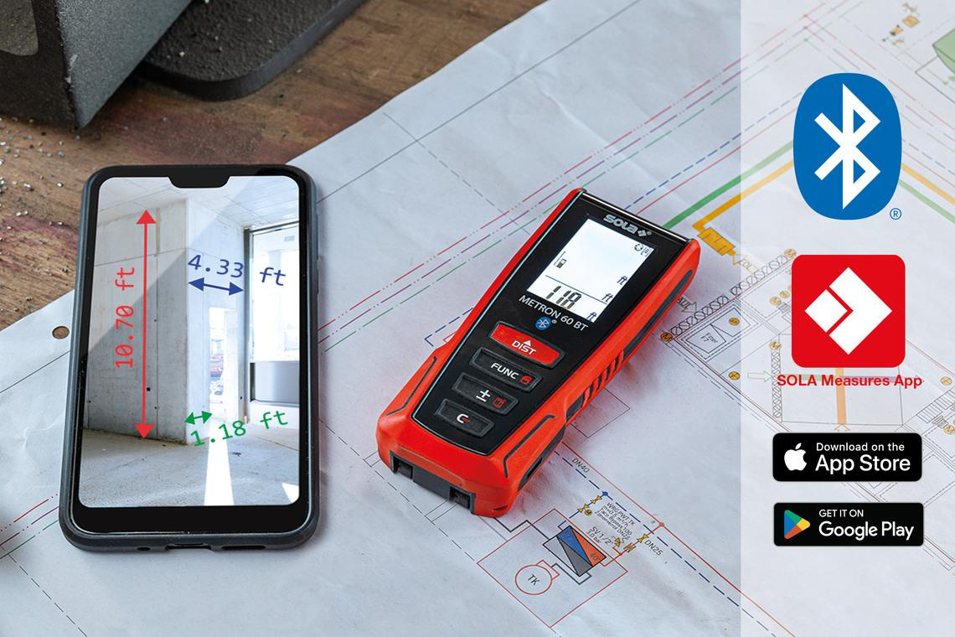
Description
A Bluetooth (Smart) Laser Distance Meter can wirelessly transfer measurements to smartphones, tablets, or computers, allowing seamless integration with CAD, BIM, and documentation software.
Features
- Bluetooth connectivity
- Mobile app integration
- Digital measurement storage
- CAD/BIM compatibility
- Automatic report generation (model dependent)
Typical Measuring Range
- 0.05–100 m
Applications
- Professional construction
- Engineering documentation
- Building Information Modeling (BIM)
- Facility management
- Digital inspection reports

Comparison of Laser Distance Meter Types
# Source: AI Source: Provided by: [Data Path: Persons Table -> ID Column: 1, Name_En Column: Motasem Essam] -> From: [ChatGPT] on [7/17/2026]
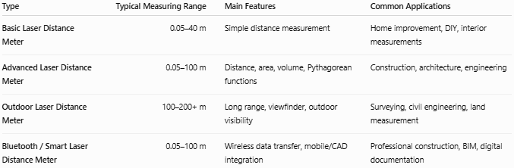
Type | Typical Measuring Range | Main Features | Common Applications
Basic Laser Distance Meter | 0.05–40 m | Simple distance measurement | Home improvement, DIY, interior measurements
Advanced Laser Distance Meter | 0.05–100 m | Distance, area, volume, Pythagorean functions | Construction, architecture, engineering
Outdoor Laser Distance Meter | 100–200+ m | Long range, viewfinder, outdoor visibility | Surveying, civil engineering, land measurement
Bluetooth / Smart Laser Distance Meter | 0.05–100 m | Wireless data transfer, mobile/CAD integration | Professional construction, BIM, digital documentation

Measuring Range
# Source: AI Source: Provided by: [Data Path: Persons Table -> ID Column: 1, Name_En Column: Motasem Essam] -> From: [ChatGPT] on [7/17/2026]
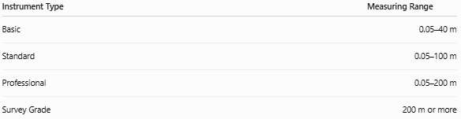
Instrument Type | Measuring Range
Basic | 0.05–40 m
Standard | 0.05–100 m
Professional | 0.05–200 m
Survey Grade | 200 m or more

Least Count (Resolution)
# Source: AI Source: Provided by: [Data Path: Persons Table -> ID Column: 1, Name_En Column: Motasem Essam] -> From: [ChatGPT] on [7/17/2026]
Typical resolution:
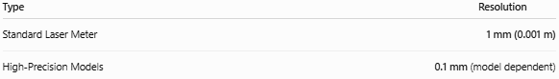
Type | Resolution
Standard Laser Meter | 1 mm (0.001 m)
High-Precision Models | 0.1 mm (model dependent)

Accuracy
# Source: AI Source: Provided by: [Data Path: Persons Table -> ID Column: 1, Name_En Column: Motasem Essam] -> From: [ChatGPT] on [7/17/2026]
Typical accuracy:
- ±1 mm
- ±1.5 mm
- ±2 mm
Accuracy depends on:
- Target surface
- Measurement distance
- Ambient lighting
- Instrument quality
- Environmental conditions

Measuring Functions
# Source: AI Source: Provided by: [Data Path: Persons Table -> ID Column: 1, Name_En Column: Motasem Essam] -> From: [ChatGPT] on [7/17/2026]
Most laser distance meters can perform:
- Distance measurement
- Continuous measurement
- Minimum/maximum distance
- Area calculation
- Volume calculation
- Indirect height (Pythagorean)
- Addition and subtraction of measurements

Example
# Source: AI Source: Provided by: [Data Path: Persons Table -> ID Column: 1, Name_En Column: Motasem Essam] -> From: [ChatGPT] on [7/17/2026]
Suppose the display reads:
8.752 m
The measured distance is:
- 8.752 m
- 875.2 cm
- 8752 mm

Sources of Error
# Source: AI Source: Provided by: [Data Path: Persons Table -> ID Column: 1, Name_En Column: Motasem Essam] -> From: [ChatGPT] on [7/17/2026]
Instrument Errors
- Calibration errors
- Weak battery
- Dirty laser lens
- Internal electronic faults

Target Errors
- Highly reflective surfaces
- Transparent materials (glass)
- Very dark or absorbent surfaces
- Uneven targets

Environmental Errors
- Rain
- Fog
- Dust
- Strong sunlight
- Heat shimmer

Observation Errors
- Incorrect reference point selection
- Measuring at an angle unintentionally
- Moving the instrument during measurement

Applications
# Source: AI Source: Provided by: [Data Path: Persons Table -> ID Column: 1, Name_En Column: Motasem Essam] -> From: [ChatGPT] on [7/17/2026]
Laser distance meters are used in:
- Construction
- Civil engineering
- Architecture
- Interior design
- Surveying
- Real estate
- Manufacturing
- Facility management
- Landscaping
- Utilities installation

Advantages
# Source: AI Source: Provided by: [Data Path: Persons Table -> ID Column: 1, Name_En Column: Motasem Essam] -> From: [ChatGPT] on [7/17/2026]
A Laser Distance Meter:
- Provides fast measurements.
- Offers high accuracy.
- Measures long distances.
- Requires only one operator.
- Performs non-contact measurements.
- Calculates area and volume automatically.
- Stores measurements digitally (many models).

Limitations
# Source: AI Source: Provided by: [Data Path: Persons Table -> ID Column: 1, Name_En Column: Motasem Essam] -> From: [ChatGPT] on [7/17/2026]
A Laser Distance Meter:
- Requires a clear line of sight.
- Performance may decrease in bright sunlight.
- Accuracy can be affected by reflective or transparent surfaces.
- Requires batteries or rechargeable power.
- Costs more than traditional measuring tools.

Comparison with Other Length Measuring Instruments
# Source: AI Source: Provided by: [Data Path: Persons Table -> ID Column: 1, Name_En Column: Motasem Essam] -> From: [ChatGPT] on [7/17/2026]
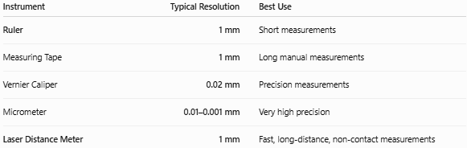
Instrument | Typical Resolution | Best Use
Ruler | 1 mm | Short measurements
Measuring Tape | 1 mm | Long manual measurements
Vernier Caliper | 0.02 mm | Precision measurements
Micrometer | 0.01–0.001 mm | Very high precision
Laser Distance Meter | 1 mm | Fast, long-distance, non-contact measurements

Care and Maintenance
# Source: AI Source: Provided by: [Data Path: Persons Table -> ID Column: 1, Name_En Column: Motasem Essam] -> From: [ChatGPT] on [7/17/2026]
To maintain accuracy:
- Keep the laser lens clean.
- Protect the instrument from impacts.
- Replace or recharge batteries regularly.
- Store it in a protective case.
- Avoid exposing it to excessive heat or moisture.
- Calibrate according to the manufacturer's recommendations.

Safety
# Source: AI Source: Provided by: [Data Path: Persons Table -> ID Column: 1, Name_En Column: Motasem Essam] -> From: [ChatGPT] on [7/17/2026]
Laser distance meters typically use Class 2 lasers, which are considered safe under normal use.
However:
- Never stare directly into the laser beam.
- Do not point the laser at another person's eyes.
- Avoid directing the beam toward reflective surfaces that may redirect it into someone's eyes.

Key Points
# Source: AI Source: Provided by: [Data Path: Persons Table -> ID Column: 1, Name_En Column: Motasem Essam] -> From: [ChatGPT] on [7/17/2026]
- A Laser Distance Meter measures distance using a laser beam.
- It performs non-contact measurements.
- Typical measuring range:
  - 40–200 m, depending on the model.
- Typical accuracy:
  - ±1 to ±2 mm
- It can automatically calculate:
  - Distance
  - Area
  - Volume
  - Indirect heights
- It is widely used in construction, surveying, architecture, and engineering.

Conclusion
# Source: AI Source: Provided by: [Data Path: Persons Table -> ID Column: 1, Name_En Column: Motasem Essam] -> From: [ChatGPT] on [7/17/2026]
A Laser Distance Meter is a modern electronic measuring instrument that uses laser technology to quickly and accurately determine distances without physical contact. With measuring ranges extending from a few centimeters to hundreds of meters and typical accuracies of ±1–2 mm, it is ideal for professional applications in construction, architecture, engineering, surveying, and interior design. Its ability to perform automatic calculations such as area, volume, and indirect height measurements makes it a highly efficient and versatile tool for precise dimensional measurement.

